19.48: Path has constant pressure, so 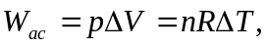 and

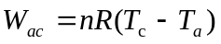
Path 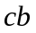is adiabatic and using 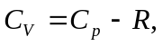

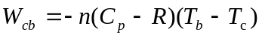

Path 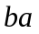has constant volume, so 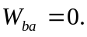 So the total work done is
